Challenger

Best Practice:

*Curve Construction*



Document Properties

**Document Version:** 0.1

**Document ID:**  CHAL-BP-001

**Document Status:** Draft

**Document Author(s):** Ben Jackson

Document Revisions List

|  |  |  |  |  |
| --- | --- | --- | --- | --- |
| Ver. | Date | Change | Author | Approved |
| 0.1 | xx/xx/xxxx | Original |  |  |
|  |  |  |  |  |
|  |  |  |  |  |

Document Status List

|  |  |  |  |  |
| --- | --- | --- | --- | --- |
| Ver. | Date | Status | Author | Signed |
| 0.1 | xx/xx/xxxx | Draft |  |  |
|  |  |  |  |  |
|  |  |  |  |  |

**Copyright © 2014, OpenLink Financial LLC All rights reserved.**

This material includes the confidential and/or proprietary information of OpenLink, is for the sole use of the intended recipient, and may be subject to the terms and conditions of a license agreement.  Without the express written consent of OpenLink and except as specifically authorized pursuant to a license agreement, no part of this material may be reproduced or transmitted in any form or by any means, electronic or mechanical, including photocopying, recording, or facsimile, for any purpose other than for the recipient’s internal use.

**Trademarks**

OpenLink®, Endur® and Findur® are the registered trademarks, and Toolkit™, Connex™, pMotion™, gMotion™, and cMotion™ are the trademarks, of OpenLink Financial LLC.  All other product and company names and marks contained in this material are the property of their respective owners and are mentioned for identification purposes only.  Other product names mentioned in this material may be the trademarks or registered trademarks of their respective companies and are hereby acknowledged as the property of their respective owners.

**Disclaimer**

OpenLink does not warrant, guarantee, or make representations concerning the contents of this material. All information is provided "AS-IS," without express or implied warranties of any kind including, without limitation, the warranties of merchantability, fitness for a particular purpose, quality and title. OpenLink reserves the right to change the contents of this material and the features or functionalities of its products and services at any time without obligation to notify anyone of such changes.

Table of Contents

1.0 Introduction 4

2.0 ABS / MBS Prepayment Curves 5

2.1 Overview 5

2.2 Curve Definition 5

2.3 Grid Point Definition 6

2.4 Input Screen 7

2.5 Output Screen 7

3.0 Recovery Rate Curves 8

3.1 Overview 8

3.2 Curve Definition 8

3.3 Grid Point Definition 8

3.4 Input Screen 9

3.5 Output Screen 10

4.0 Survival Curves 11

4.1 Overview 11

4.2 Curve Definition 11

4.3 Grid Point definition 12

4.4 Input Screen 13

4.5 Output Screen 13

5.0 Basis Swap Curves 15

5.1 Overview 15

5.2 Curve Definition 16

5.3 Grid Point Definition 17

5.4 Input Screen 18

5.5 Output Screen 19

6.0 OIS Curves 20

6.1 Overview 20

6.2 Curve Definition 20

6.3 Grid Point Definition 22

6.3.1 Cash Grid Points 22

6.3.2 Quoted OIS Swap Grid Points 22

6.3.3 Fed Fund/Libor Basis Swaps 22

6.4 OIS Rate Approximation 23

6.5 Creating the Benchmark (LIBOR3M) Projection Curve with OIS Discounting 24

6.5.1 Libor3M_OIS.USD 24

6.6 Creating curves for other Libor Tenors and Basis Curves with OIS Discounting 25

6.6.1 Libor1M_OIS.USD 25

6.7 OIS Based Valuation Analysis 26

# Introduction

This document is intended to give a high level, best practice approach to modelling some common curve and index structures in the OpenLink system.

# ABS / MBS Prepayment Curves

## Overview

These curves are needed to project relevant prepayments on ABS and MBS. For the latter, Findur relies on the PSA Prepayment Model. This prepayment model was first developed by the Bond Market Association (formerly known as Public Securities Association or PSA). It assumes increasing prepayment rates for the first 30 months of the lifetime and constant rates thereafter. For ABS, different prepayment curves will be needed; however, the curve construction logic will be the same as in MBS.

## Curve Definition

The standard model (also called "100 percent PSA") works as follows: starting with an annualised prepayment rate of 0% in month 0, the rate will increase by 0.2% each month, until it peaks at 6% after 30 months. From the 30th month on the model assumes an annual conditional prepayment rate of 6%. Variations of the model are expressed in percent. For example, a 150% model means a monthly increase by 0.3%, until the peak of 9% is reached after 30 months. The months thereafter will have a constant annual prepayment rate of 9%[1].

In Findur, the user can create a prepayment curve per instrument or can leverage a predefined curve. The former case is done for instruments with uncommon pools. Uncommon pools will probably require special modelling of pool prepayments. Nevertheless, for standard pools, predefined curves may be used. For example, if five mortgage-backed securities have similar 120 PSA pools, the user can simply create a 120 PSA curve and link it to these five securities.

These curves are still considered ‘Fixed Income’ curves; however, their group is ‘Mortgage’ and their purpose is to model prepayment. These curves should never be used to project, for example, forward interest rates. They can only project pool pre-payments.

Brief definition summary:

* **Market**: Fixed Income
* **Group**: Mortgage
* **Format**: Price.
* **Purpose**: Prepayment
* **Delivery Unit**: SMM (Single Month Mortality)
* **Base Currency**: USD for the example of a FNMA mortgage-backed security.
* **Base Ccy Holiday**: NYC for the example of a FNMA mortgage-backed security.
* **Interpolation**: Log-Linear.

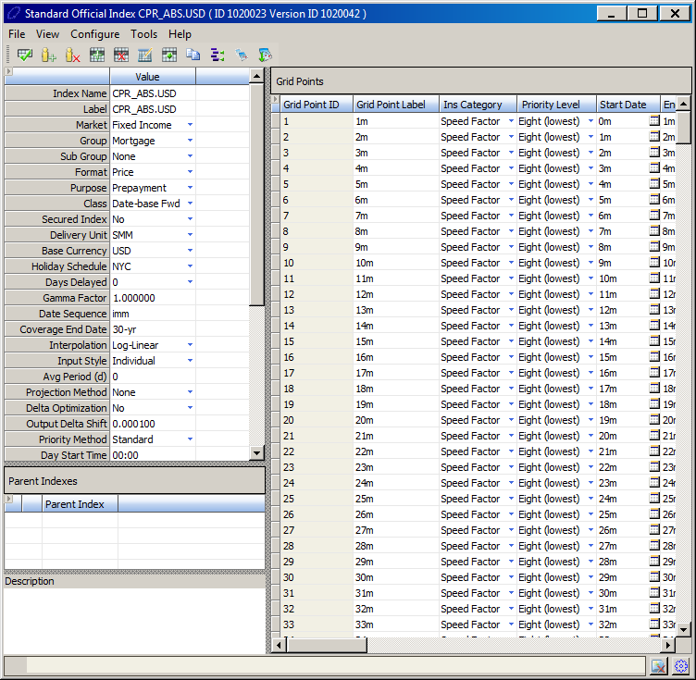

## Grid Point Definition

All grid points need to be set to ‘Speed Factor.’

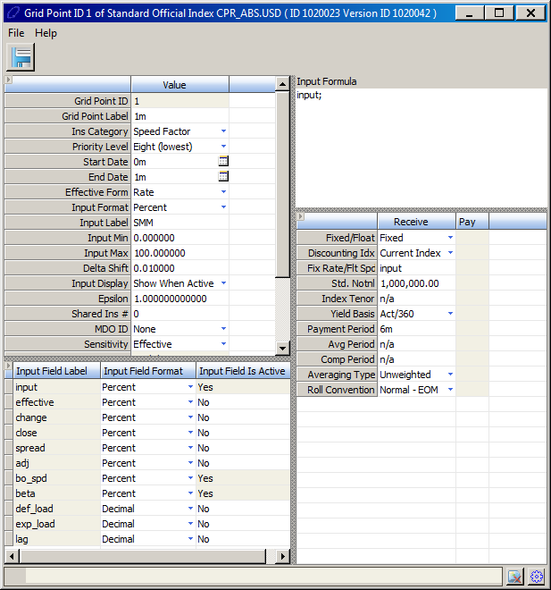

## Input Screen

The input screen can default to 100 PSA like the one below; however, copies can be made to construct the 150 or 200 PSA. Moreover, if the user has his own pre-payment model, he can override the single monthly mortality values of the input screen and leverage the rest of Findur’s functionalities on the matter.

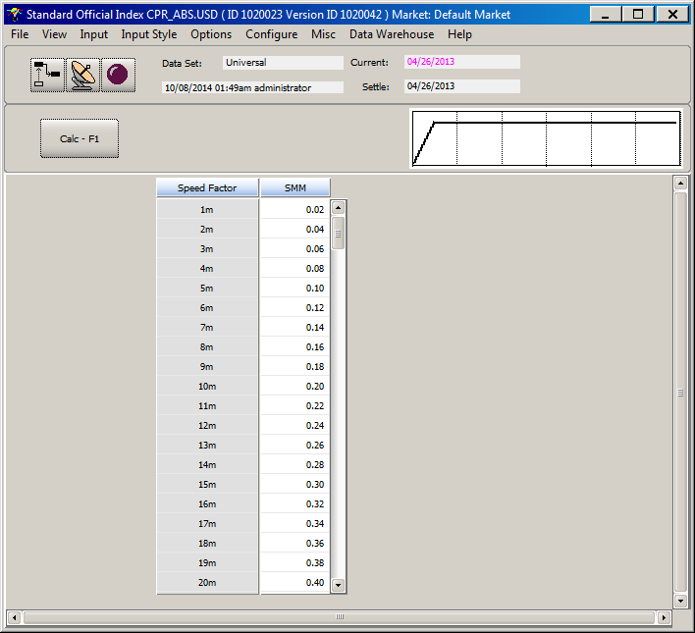

## Output Screen

The output screen will display the single monthly mortality path of the PSA model.

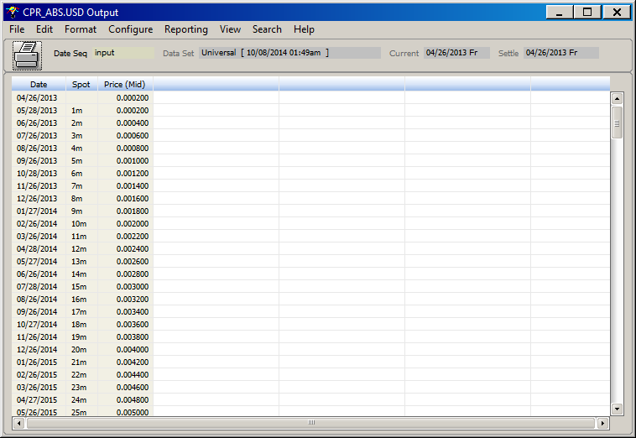

# Recovery Rate Curves

## Overview

This curve is needed to price Credit Default Swaps (CDS). It represents the recovery rate assumptions over time of the underlying asset with credit risk (i.e. a bond). This curve is used to create time-varying recovery rates. The output of this curve is recovery rates that are stripped for each projected contingent payment date.

## Curve Definition

Brief definition summary:

* **Market**: Recovery
* **Format**: Price.
* **Purpose**: Trading
* **Interpolation**: Log-Linear.

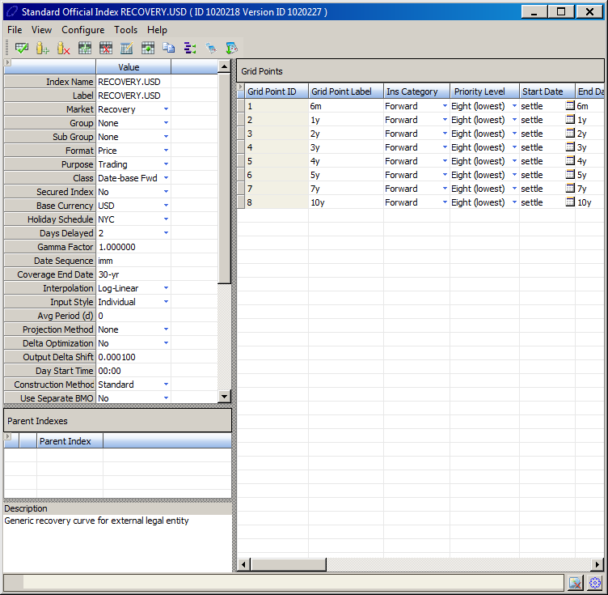

## Grid Point Definition

All grid points need to be set to ‘Forward.’

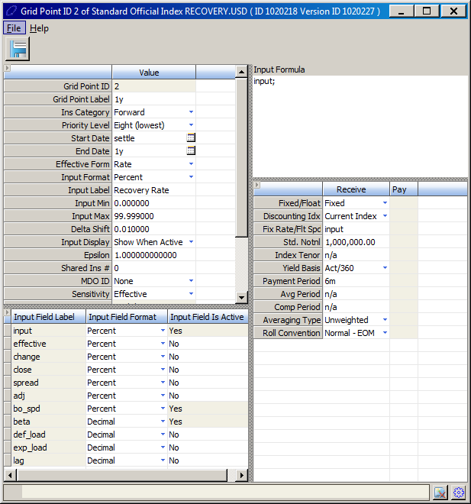

## Input Screen

In the U.S. and Europe it is market practice to set constant recovery rates to 40%. This assumes that, in case of a default related to the underlying asset, the holder of the asset will only recover 40% of the asset’s par value.

This curve can be shared throughout all CDS’s; however, if the 40% recovery rate assumption does not apply to a different market, a second curve can be added with a different assumption. In addition, the rate does not have to be constant. The user can add a step up/down or rollercoaster assumption.

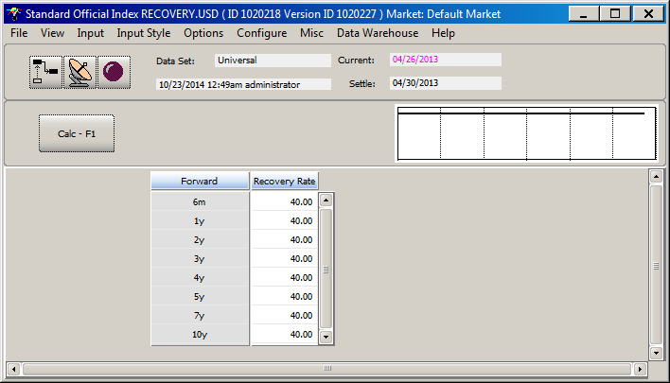

## Output Screen

As mentioned before, the output of this curve is recovery rates that are stripped for each projected contingent payment date.

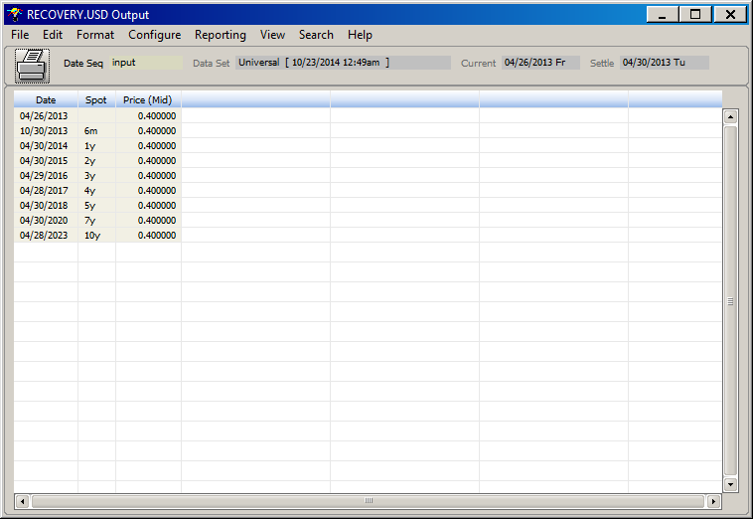

# Survival Curves

## Overview

The market standard to construct a survival probability curve is to input CDS swap rates. These rates can be defined as grid points on the survival probability curve.

Given that the credit risk that a CDS swap is attempting to hedge is per debt issuer, a survival curve per CDS will be needed. For example, if the client wants to trade a CDS on debt issued by Bank of America, a specific survival curve for BofA will be needed.

It is important to mention that survival curves by credit rating can also be used. For example, a sovereign survival curve with implied government probabilities of default can be used for government CDS. Following the same logic, survival curves for corporates by credit rating can be implemented. These can be particular useful in cases where institution specific CDS spreads are not available.

## Curve Definition

This methodology requires the curve to reference two parent indices: the Recovery curve and the interest rates curve (i.e. LIBOR.USD). The information on these curves is required in order to back out the survival probability from CDS swap rates.

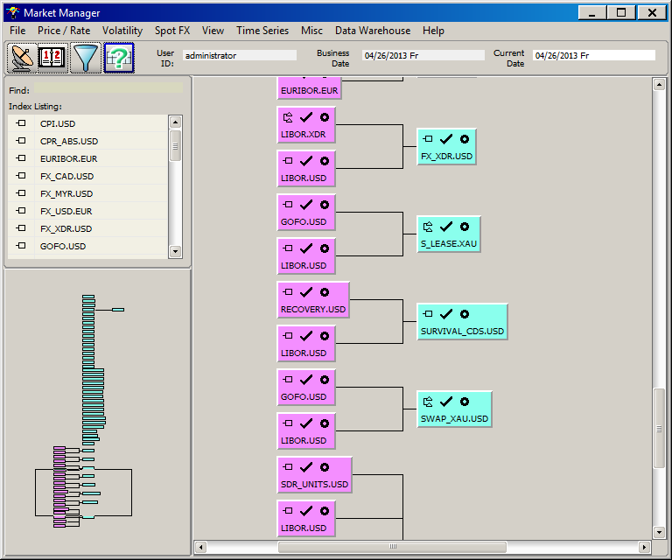

An important field on this curve definition screen Interpolation. Choosing a method with which to interpolate the survival probability curve can make significant differences in the pricing of a CDS. The market standard is to interpolate the survival probability curve using log-linear interpolation. This implies piecewise constant instantaneous hazard rate structure.

Brief definition summary:

* **Market**: Fixed Income
* **Format**: Survival
* **Purpose**: Trading
* **Interpolation**: Log-Linear
* **Discount Index**: LIBOR.USD
* **Parent Indices**: Recovery Rate and LIBOR.USD

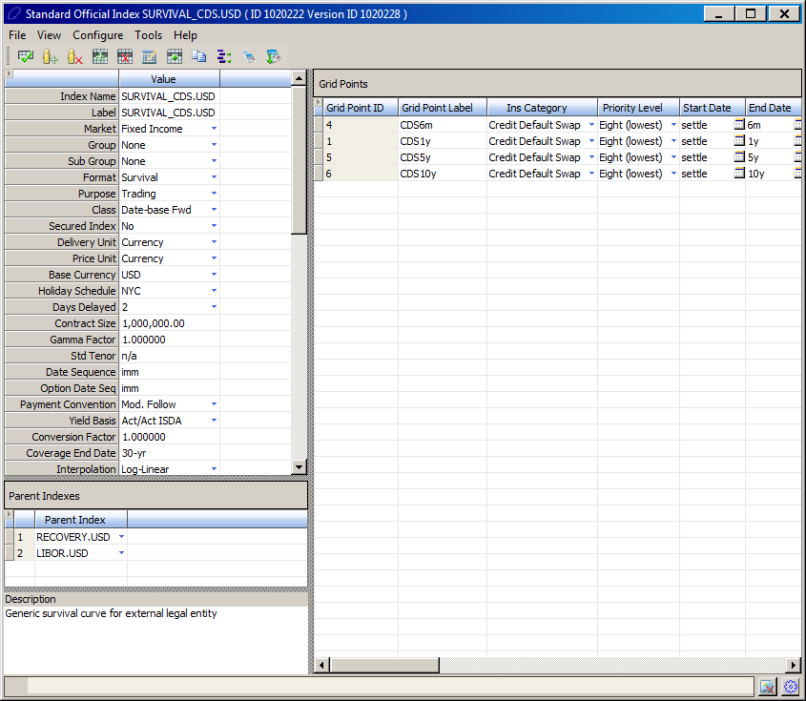

## Grid Point Definition

Within the grid point definition, the attributes of the CDS spread used as input are defined. Given that CDS are usually quoted in basis points, ‘BPS’ has been specified in the ‘Input Format’ field.

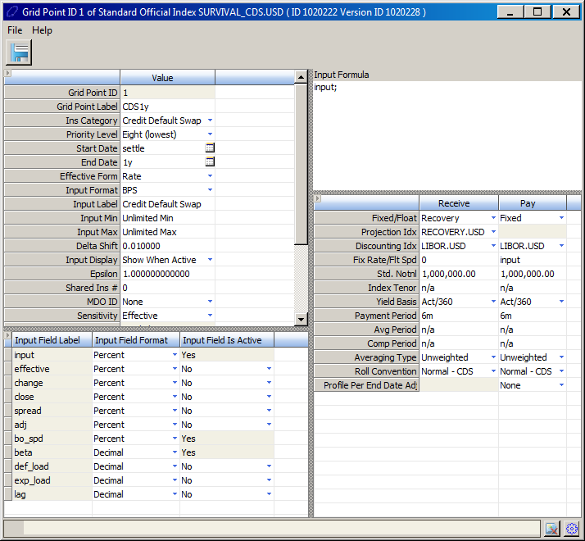

## Input Screen

The input screen will capture those CDS rates for the relevant maturities.

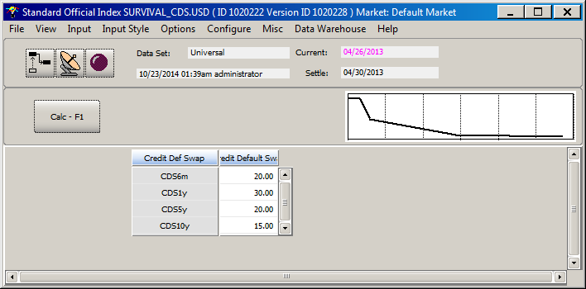

## Output Screen

The output screen will display the implicit hazard rate and probability of default based on the CDS rates.

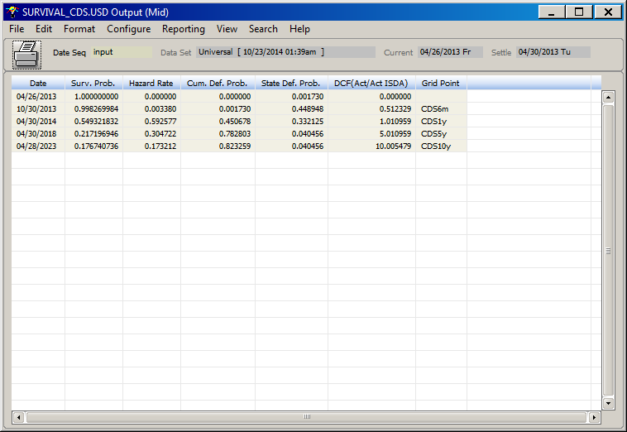

# Basis Swap Curves

## Overview

Basis swap adjusted yield curves are used to take into account the effect of non-Libor funding. The funding rates in foreign currencies are usually available via basis swap spreads. A basis swap is a floating vs floating cross currency swap, which involves an exchange of principal (e.g: USD Libor vs JPY Libor +/- spread). The spread is always assumed to be on the non-USD side of the swap.

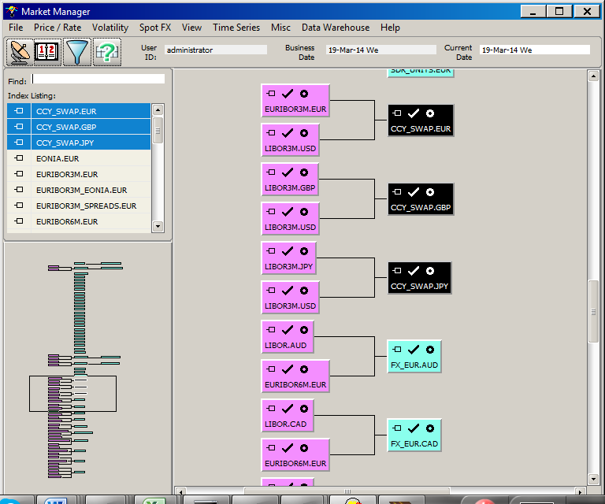

## Curve Definition

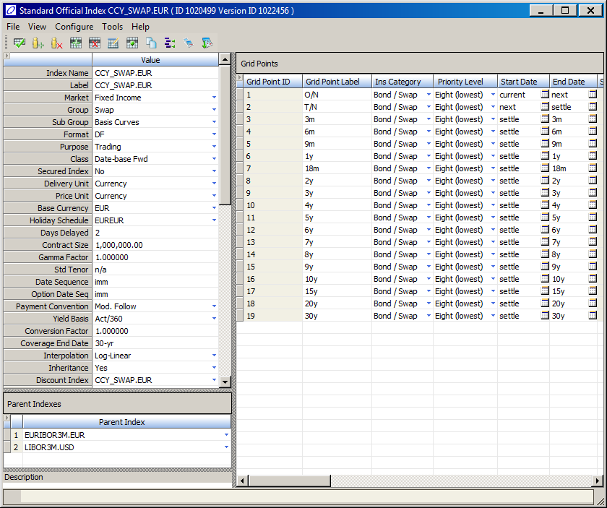

## Grid Point Definition

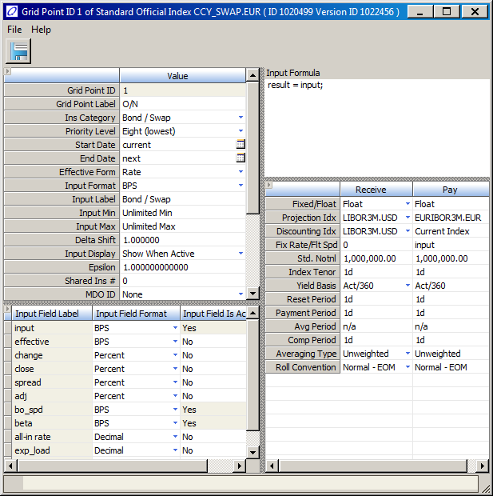

## Input Screen

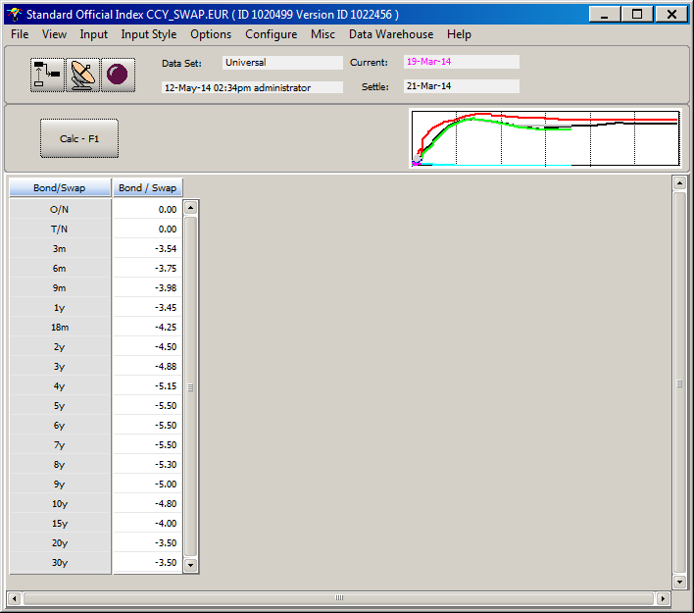

## Output Screen

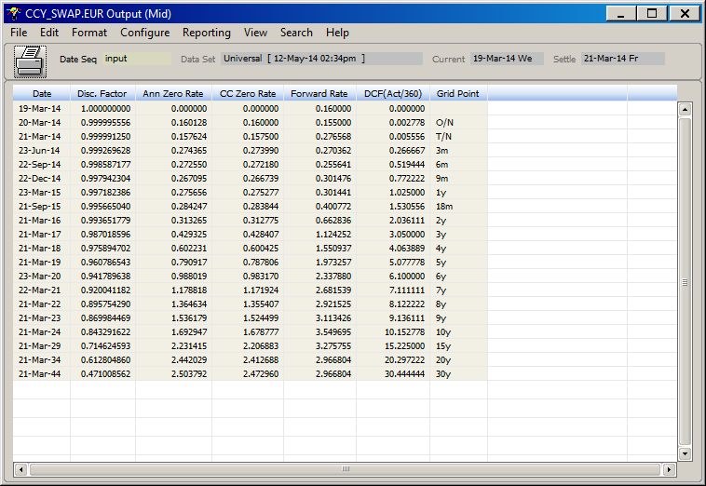

# OIS Curves

## Overview

The OIS curve is now considered to be the best proxy for the “risk free” rate and is used for discounting collateralized transactions while a separate curve, which matches the maturity of the underlying floating rate and is conditional on the OIS rates used for discounting, is employed for the projection of forward rates.

The purpose of this document is to provide direction on OpenLink’s approaches to OIS curve construction, configuration and usage. This curve will be used primarily for discounting, but also as a projection curve for OIS indexed trades, such as FedFund swaps or OIS swaps. While the focus here is on the USD market and its associated OIS curves, the recommendations described herein can be applied in the same manner for other currencies that have adopted OIS discounting.

## Curve Definition

OpenLink currently has two approaches to constructing the OIS discounting curve:

* An iterative process which bootstraps the OIS curve using synthetic FedFund (FF) basis spreads (obtained by pairing up FF/Libor3M basis swap and Libor3M fixed/float swap to eliminate the Libor leg). This method is similar to the so called dual curve bootstrap, a term used by other industrial sources (e.g. Eris Exchange)
* A formula-based approximation of OIS swap rates utilising Libor 3M swap rates and Libor3M/FF basis swap rates and accounting for compounding differences (e.g a Bloomberg-like curve)

|  |  |  |
| --- | --- | --- |
| Instrument | Category | Coverage |
| OIS Based Cash Deposit | O/N, Cash Rate | Overnight to 1Y |
| Quoted OIS Swaps | Bond/Swap | 1Y to 5Y |
| FF/Libor Basis Swaps | Bond/Swap | 7Y to 30Y |
| Extrapolated Libor/FF Basis | Bond/Swap | >30Y |

For the extrapolated gridpoints (>30Y), we assume a constant Libor/FF Basis beyond the last quoted (30Y) basis swap.

Brief definition summary:

* **Index Label**: Generally set as a copy of the index name but can be changed. It is only used for reporting purposes.
* **Market**: Fixed Income.
* **Group**: Swap. Used for reporting and grouping purposes.
* **Sub-group**: User defined. Can be added to for grouping and querying purposes.
* **Format**: Always DF. This is the type of output that the interpolation selected below will act upon.
* **Purpose**: Always “Trading,” which it needs to be in order to be selected on the deals.
* **Secured Index**: Could be set to ‘Yes’ if restrictions on modification are wanted to be set at the user level in the user maintenance.
* **Base Currency**: The main currency, which should equal the bought currency.
* **Holiday Schedule**: For non-LIBOR curves, this is the main holiday schedule for that currency. For LIBOR, this is set to the LDN holiday schedule to reflect the holidays of the business centre. EURIBOR.EUR uses the Euro Target schedule.
* **Days Delayed**: This is the default number of business days that will separate a fixing on this curve from the start of the term of the fixing, i.e., delay of delivery of the currency. For a description of this per currency, please see the grid-point section below.
* **Payment Convention**: This serves as a default on deals when the curve is selected. It is also used in the bootstrapping process. This is set to ‘Follow’ for the main discounting indices, but ‘Mod. Follow’ is also sometimes used.
* **Yield Basis**: This is solely a default on deals when a curve is selected.
* **Coverage End Date**: The symbolic date to which the curve’s output will be calculated.
* **Interpolation**: Usually Log-Linear. This interpolation is applied to the format of the curve, as named above, which is a discount factor in all cases. This combination tends to give the smooth output, and also has the virtue that the implied forward FX curves can be built with an interpolation scheme that providing no arbitrage across all time-points.
* **Reference Source**: Again a default for deals when the curve is selected as a projection index.
* **Delta Optimization**: When set to ‘Yes’ this will speed delta calculations by assuming zero delta on deals for grid-points out way-beyond the maturity of that deal. This can only be set to ‘Yes’ when this assumption is valid – true for most discounting instruments, and when the curve formulae do not access later points. It is advised during implementation that, if this assumption is true the delta optimization is left on; otherwise, switch this to ‘No’.

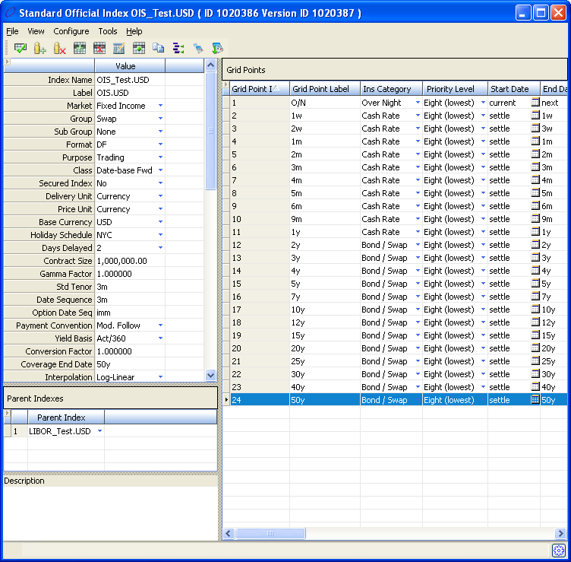

## Grid Point Definition

### Cash Grid Points

These are OIS based cash deposit instruments (with daily compounding) and have a payment period of 1y.

### Quoted OIS Swap Grid Points

For swaps under 7 years, we use directly observable OIS swap rates as the input.

### Fed Fund/Libor Basis Swaps

For these swap grid points, the receive side will obtain the required fixed rate from the input value to the grid point on the parent Libor curve that has the same maturity date. In the figure below for example, the input value to the 5y grid point on the Libor parent curve will be used as the input to the fixed side of the 5y swap grid point on the OIS.USD curve. Similarly, the float side of the swap will take as its floating spread the input value from the FF basis parent curve’s grid point with the same maturity. This input value is assigned to the grid point input field “adj”.

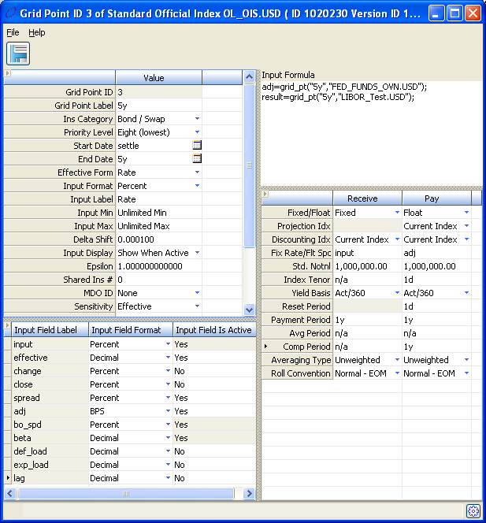

## OIS Rate Approximation

Here, let A,B and C denote the N-year Libor swap rate, OIS rate and FF basis spread, respectively. The OIS rate can then be approximated as:

=

Where :

The below adjustment is then applied to obtain the OIS rate with compounding adjustment

This formula is replicated in the Endur/Findur application as shown below.

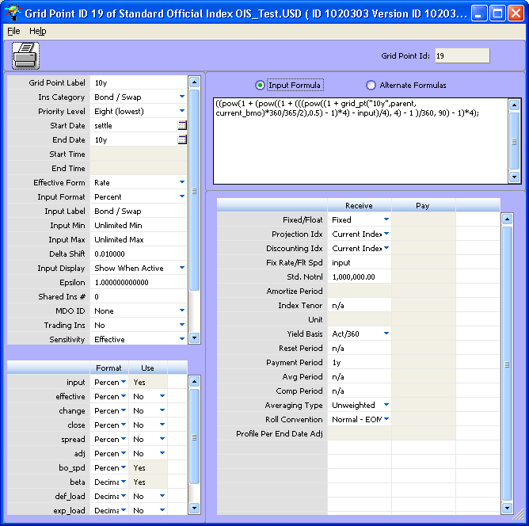

## Creating the Benchmark (LIBOR3M) Projection Curve with OIS Discounting

### Libor3M_OIS.USD

This curve is to be used only as a projection curve for 3M collateralised trades paired with OIS discounting. The parent to this curve is the previously constructed OIS.USD curve. The building blocks are the same as for the conventional Libor curve (3M Cash, EURO Dollar Futures, Libor Par Swaps). Both the Cash and Futures gridpoints are set up in the same manner as for the conventional Libor curve and will use “current” for the discounting index while the Swap grid points will use OIS.USD as discounting on both legs of the swap.

#### Swap Grid Point

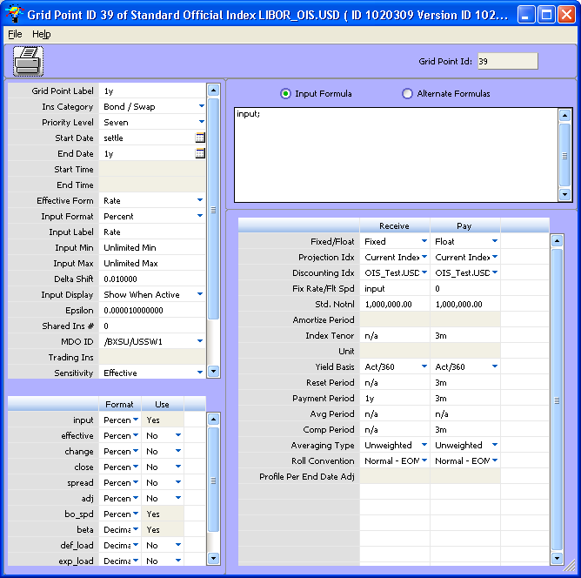

## Creating Curves for Other Libor Tenors and Basis Curves with OIS Discounting

### Libor1M_OIS.USD

This curve is to be used only as the projection curve for 1M collateralised trades paired with OIS discounting. The parent to this curve is the previously constructed OIS.USD curve. The building blocks for this curve are:

* 1M Cash Deposit (using ‘Current’ as the discounting index on the cash instrument); and
* Libor1M/3M basis swaps (the 1M side will use ‘Current’ as its projection index and the 3M side will use the previously constructed Libor3M_OIS.USD as its projection index. Both sides will use OIS.USD as the discounting index).

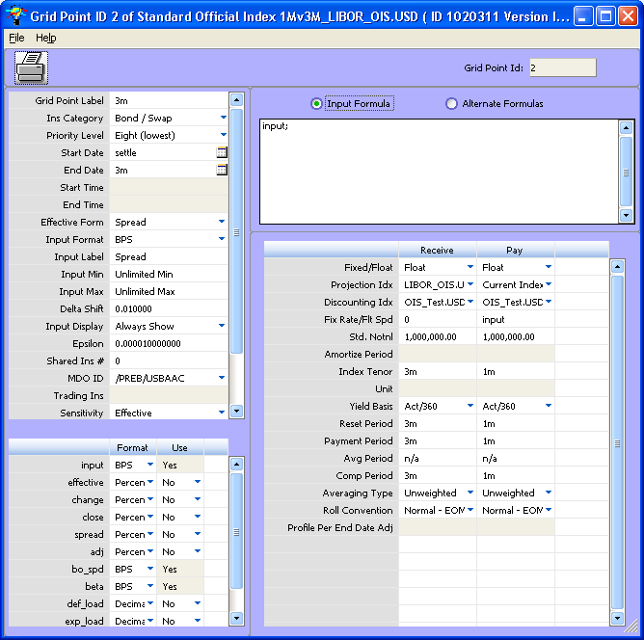

A similar approach can be used for other Libor tenors such as 6M and other basis curves such as SIFMA and PRIME. For each of these curves, the Cash Deposit point(s) shall be consistent with the index and the basis swaps are respective basis swaps against Libor.

## OIS Based Valuation Analysis

We recommend that users continue to book deals and perform their required EOD and risk reporting using their conventional or uncollateralised curves, at least initially. A separate set of OIS based curves should be implemented and maintained in the application and should only be used for ad hoc valuation and risk analysis; only after these curves become more widely accepted and their results better understood should they be incorporated into all areas of the application. For ad hoc valuation using OIS discounting, users can set up a Reval simulation with the following curve mappings:

* For projection indexes, map the relevant uncollateralised curves to their respective OIS based projection curves; and
* For discounting, map the Libor3M uncollateralised curve to OIS.USD.

1. Please refer to OLF’s standard documentation for more on ABS prepayment curves.